

Department of Computer Science and Engineering
20 CS-PC-322 & Machine Learning and Data Science
Mid-1 Assignment Questions

YEAR / SEM: III / II Academic Year: 2023-24
____________________________________________________________________________
Note: There are 4 sets of Assignments, and submit the assignments as per following Pattern for each Section:

Set-1 Assignments submit by First 16 students
Set-2 Assignments submit by Next 16 students
Set-3 Assignments submit by Next 16 students
Set-4 Assignments submit by Remaining students

SET -1
S. No. | Questions. | BTL | COs | POs, PSOs
 | What are vectors in machine learning? Explain with examples the different operations performed on them. | L1 | CO1 | 2,3,6,12,1
 | Explain Simpson’s paradox. | L2 | CO1 | 2,3,6,12,1
 | What is train/test split of data and Inspect it is implemented in machine learning? | L3 | CO2 | 2,3,6,12,1
 | Explain in detail about Naïve Bayes algorithm. | L2 | CO2 | 2,3,6,12,1
 | Explain find –S algorithm with given example (refer Table 1). Give its application. | L2 | CO3 | 2,3,6,12,1
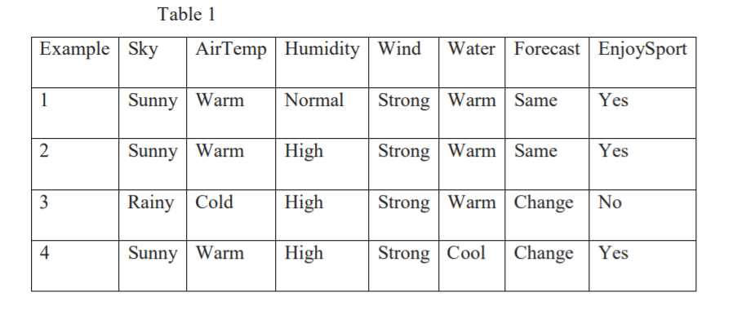
SET -2
S. No. | Questions. | BTL | COs | POs, PSOs
 | Discuss about Center Limit Theorem and Central Tendencies | L2 | CO1 | 2,3,6,12,1
 | Discuss about statistical hypothesis testing. | L2 | CO1 | 2,3,6,12,1
 | Illustrate K-Nearest Neighbours with an example. | L3 | CO2 | 2,3,6,12,1
 | What are the four components of time series? How do you analyze the time series? | L2 | CO3 | 2,3,6,12,1
 | Give an over view of Deep Learning. | L2 | CO3 | 2,3,6,12,1

SET -3
S. No. | Questions. | BTL | COs | PO, PSOs
 | What is P-hacking? Explain with an example | L1 | CO1 | 2,3,6,12,1
 | Discuss Bayesian Inference. | L2 | CO1 | 2,3,6,12,1
 | What do you mean by regularization? Explain the different regularization methods. | L2 | CO2 | 2,3,6,12,1
 | What is meant by random forest algorithm? Explain | L2 | CO2 | 2,3,6,12,1
 | What is a neural network explain in detail | L2 | CO3 | 2,3,6,12,1

SET- 4
S. No. | Questions. | BTL | COs | POs, PSOs
 | Explain about matrices and the operations performed on matrices. | L2 | CO1 | 2,3,6,12,1
 | Explain about correlation and causation. | L2 | CO1 | 2,3,6,12,1
 | Discuss about Support Vector Machines (SVM). | L2 | CO2 | 2,3,6,12,1
 | Discuss in detail about Classification Errors. | L2 | CO2 | 2,3,6,12,1
 | Explain the process of learning by rule induction with an example. | L2 | CO3 | 2,3,6,12,1

